STUDENT HANDBOOK

Montpelier High School 2023-2024
Montpelier School believes that each student is unique, capable of learning, has potential, and is able to attain personal goals; Montpellier School is preparing students to succeed in a changing world while supporting students’ emotional and physical well-being.

Introduction
The following notes are derived from the school’s policy book which can be found on the school’s website at www.montpelier.k12.nd.us. This document is not official policy, but rather is a handbook designed to make policy more easily understood in an attempt to empower students and teachers in order that students can gain the knowledge they need to make their own worlds a little bit better. If clarification is needed, policy should be consulted.
Complaints:
A complaint is an official way of complaining about something for which students think they were wronged. In the policy book there is an official grievance procedure. Below is a simple guideline explaining to students the best way to handle complications which arrive due to behavior of other students, teachers, or staff members.
If a student is in a position where another person at Montpelier School has caused offense, harm, or is otherwise acting inappropriately, these are the steps to follow:
- Maintain calm. Confront the person who has caused the offense in a non-violent way. Most conflicts are caused by a lack of communication and as a result, most conflicts are resolved by good communication.
- If #1 is ineffective, it may become necessary to bring a third party into the conversation. A trusted teacher, administrator or counselor should be consulted.
- If #’s 1 and 2 both prove ineffective at resolving the conflict, it might be time to follow the official complaint procedure found in the policy book. If the complaint procedure in the policy book is intimidating or unclear, consult a teacher, counselor, or administrator to help you with the process.
If a complaint needs to be filed, please contact:
Phil Leitner
214 7th Avenue
Montpelier ND 58472
Telephone: 701-489-3348
phil.leitner@k12.nd.us

Student Information:
The school does keep personal information about students. Parents and people the parents authorize are always welcome to view the contents of their child’s files. The school may release student information to teachers and other school personnel but only if those people have a legitimate educational interest in the student.
Attendance
Enrollment:
(Policy: Students ST 6000):
All students in grades 9-12 shall enroll in at least four units each semester in addition to physical education and music. Students participating in the Vocational Center in Jamestown shall have two hours of classwork there. No student shall have more than 1 and ½ periods of study hall per day.
Students enrolled in Montpelier High School may take a subject by correspondence even if the course is offered in this school; however the student must pay for the course. All correspondence courses must be approved by the administration.
A student is not able to drop or add a class after the first five days of the semester unless there is special permission from administration. Also, any change must be approved by parents.
Absenteeism :
An absence is defined as being 10 or more minutes late to class. If a student is gone from school, the school does need to be notified by parents prior to the student being absent. This is especially important in the winter for safety reasons. Either the school or parents do need to know the location of students.
If a student needs to leave school during the day, there does need to be communication between the school and parents prior to the student leaving.
When a student returns from an absence, it is the student’s responsibility to communicate with teachers in order to determine what was missed which might impact the student’s education. The teacher will decide how much time is allotted for that student to make up the work.
Students should never miss more than 10 periods of any class during the course of the semester. If more than ten absences occur, the student will be required to make up time missed hour for hour. This will be done with an agreement with the educator and principal on extra work. Students who have missed more than 10 periods of any class during the course of the semester will receive an incomplete grade and have two weeks after the grading period to make up the time. Any student who has not made up the time during that time period will receive an “F” as a grade. Students may appeal to the School Board to receive credit for the class.
Tardiness:
During any period of the day, if a student is late for a class they may be marked tardy. Tardiness is defined as being 9 or less minutes late to class. A student will be given one absence for every 4 tardies they accumulate throughout the semester. Penalties for absences are addressed in the absenteeism portion of the student handbook.

Academics
Graduation Requirements:
The following 22 units of high school coursework constitute the minimum requirement for high school graduation. Courses taken prior to grade 9 do not count toward graduation.
- 4 units of English
- 3 units of Mathematics
- 3 units of Social Studies including 1 credit P.O.D., 1 credit U.S. History,and 1 credit social studies elective.
- 3 units of Science including Physical Science and Biology
- 3 units of 1. Foreign Languages, 2. Fine Arts, or 3. Career and Technical Education Courses
- 1 unit of Physical Education or ½ unit of PE and ½ unit of Health
- Any 5 additional units
- Total of at least 22 units
- Must be ND Choice Ready* as defined by the North Dakota Department of Public Instruction (starting with the Class of 2025)
- All requirements for graduation must be completed before the date of graduation in order for a student to participate in the graduation exercises.
- Any senior involved with a correspondence class must complete the course or courses by May 15 to count for graduation.
- All students must attend eight (8) semesters of school in grades 9-12 before graduating. Exceptions must be approved by the Montpelier School Board after being requested by the student and the student’s parent(s).
- Any student that will not be ND Choice Ready by the date of graduation can apply for an exemption to the requirement by petitioning the high school principal. The request will be heard by a staff committee consisting of 4 teachers and the high school principal. The committee will consider the student’s dedication and ability to achieve ND Choice Ready standards when deciding to approve or deny the request.
- An IEP may lessen graduation requirements provided the student still meets state graduation requirements.
* ND Choice Ready information is found at the following address: https://www.nd.gov/dpi/districtsschools/essa/accountability-support-improvement/choice-ready

Incompletes:
A student may be given an incomplete for the following reasons:

- At the discretion of the administration and educator due to extenuating circumstances.
- If a student fails to complete any assessment (projects, tests, ext) as determined by the educator.

Any student who still has an incomplete after two weeks past the grading period will receive a grade of an “F” in the class no matter the percentage.

Honor Roll:
- Students having a GPA of 3.0 (B Average) or higher will be designated ‘Honor Roll Students’. A “D” or “F” will disqualify that student from the honor roll. The honor roll is calculated every quarter.
Honor Students:
- Students who graduate with a GPA of 3.0 or above will be named ‘Graduated with Honors’ at graduation. The student with the highest GPA will be named Valedictorian at graduation and the
second highest GPA will be named Salutatorian. Foreign Exchange Students are not eligible for either the valedictorian or salutatorian award.
Student Behavior
Student behavior will be classified on four levels to emphasize the importance of Pride in Self, Pride in Others and Pride in School.
Level 4 Behavior:
- Level 4 behavior is exemplary behavior where students take pride in their school, their education and hold themselves to the highest standard.
Level 3 Behavior:
- Level 3 behavior is expected behavior. Students are ready to learn, collaborate with others, are respectful and show pride in their school.
Level 2 Behavior:
- Level 2 behavior is behavior that is unacceptable and students will receive reminders of appropriate behavior. Multiple level 2 behaviors will result in a referral (detention)
Level 1 Behavior:
Level 1 behavior is behavior that has completely unacceptable behavior in a school setting. An immediate referral (detention) or greater will occur.
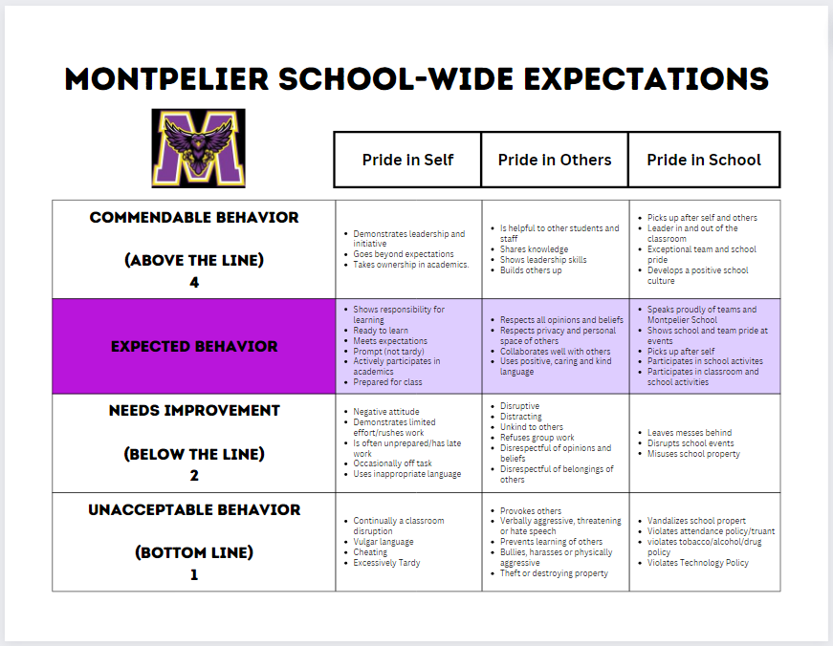
Disciplinary Referral:
Students will receive detention at the discretion of the administration for violations of any school rules.
All detentions will be arranged by the principal. Failure to comply with the rules of detention will result in a half day in-school suspension.
In-School Suspension:
In-School Suspension is given by an administrator. Reasons for In-School Suspension may include (but are not limited to):
- Cheating
- Not Serving Detention
- Being tardy 10 or more times within a semester
- Any Severe Behavior (as determined by the administrator)
- Having three disciplinary detentions
School work done during in-school suspension plus any extra work assigned by the teachers must be handed in upon return to class. Students are responsible for communicating with teachers before or after school in order to understand what schoolwork needs to be completed. Students do NOT get extra time for schoolwork assigned during In-School Suspension.
Out of School Suspension:
The principal or superintendent may suspend any pupil from school for:
- Disorderly Conduct
- Use or possession of tobacco, alcohol, narcotic drugs, or any controlled substance
- Willful conduct which materially and substantially disrupts the rights of others to an education
- Stealing or willful conduct which endangers the student, other students, or school property • Skipping class
- Possession of firearms, knives, explosives, or other dangerous objects on school property
- Three in-school suspensions
All school work must be completed before being readmitted to class after a suspension. After three out of school suspensions, the superintendent may recommend to the school board that the student be expelled.
School work done during out of school suspension plus any extra work assigned by the teachers must be handed in upon return to class. Students are responsible for communicating with teachers before or after school in order to understand what schoolwork needs to be completed. Students do NOT get extra time for schoolwork assigned during Out-Of-School Suspension. Credit received for schoolwork completed during an out-of-school-suspension is up to the discretion of the teacher.
Expulsion:
Expulsion may be imposed by the School Board upon recommendation by the superintendent.
Bullying
If you feel you are being bullied, talk to a teacher or administrator. If the situation does not get resolved, there is a form online which can be used to file an official complaint.
Drug Use and Abuse
Montpelier School will educate students about drug and alcohol abuse in an age-appropriate program.
Students are not allowed to possess or be under the influence of alcohol, any controlled substance including but not limited to marijuana, any narcotic drug, any hallucinogen, any stimulant, or any depressant unless dictated by a prescription. Also included in the prohibited substance list is any abusable glue or aerosol paint which could be used for inhalation.
If students are found in violation of the Drug Use and Abuse Policy (look in the Policy for further explanations), they may be suspended or expelled. In addition, if the violation of the policy also violates the law, law enforcement will be notified.
Tobacco and Vape:
Students possessing or using tobacco on school grounds will result in an In-School Suspension. In addition law enforcement will be notified.
Drug and Alcohol Abuse as Related to Extracurricular Activities
Use or possession of tobacco, alcohol, narcotics, or other harmful substances in or out of school will result in a student being suspended from any game participation or public appearances for a period of six weeks from the date of the infraction for the first offense and 18 weeks for any subsequent offense.

The School Day
Driving Cars:
Students are prohibited from driving during the school day without approval from administration. Students need to keep driveways and bus loading areas clear. Students driving need to be very careful and drive slowly on school grounds.
Telephone Calls:
Local calls from the school by students should be made only in cases of emergency. Students will not be called out of class for a phone call unless it is an emergency.
Gymnasium:
Students are not allowed to participate in activities which might cause injury including basketball, weight-lifting, or other athletic activity unless supervised by a teacher or administration.
Lunchroom
Do not push in line. Be nice to each other. When done, take your tray and utensils to the disposal area. Use good manners.
Dress Code
Personal grooming and dress are primarily matters of concern between the students and their parents. When grooming and dress create a disruptive influence upon the education program of the school or when the health or safety of the student body is affected, it becomes a concern of the school. Students are encouraged to use sound judgment and modesty in dress and grooming. Any student who is wearing a situationally inappropriate item of clothing will be provided with something appropriate to wear. Students shall wear situationally appropriate dress when attending school sponsored functions.
- Any shirt, blouse, hat or any article of clothing that refers to an alcohol or tobacco item or is vulgar, profane, or
- Any item of clothing that is situationally inappropriate or is a disruption to the school environment as defined by school staff may not be worn at school functions or on school property.
- Hats may be worn inside the school building, but should not be worn in the lunchroom. Hoods may not be worn inside the school building.
Dismissal
Class starts at class start time. Class ends when the teacher dismisses the students. If a teacher holds a class longer than allows students to get to the next class period on time, that teacher will contact the students’ next period teacher letting them know that those students should not be counted tardy.
Emergencies
In case of a serious accident or other medical emergency, parents will be notified immediately. The school will take action if parents cannot be reached.
Lockers:
Your locker is the property of the school. School personnel (administrators, teachers, counselors, secretaries, etc) can inspect any locker at any time for any reason. No lock is to be placed on a locker unless permission is obtained from administration. The locker room is not a storage area for anything except for Physical Education and other Athletic purposes. Books, coats, etc. should be kept in the hall locker. Items left in the locker rooms or hallways may be disposed of. Backpacks should also stay in the lockers and will not be allowed in classrooms. A student only has access to the locker assigned to him or her at the beginning of the school year unless other arrangements are made between the student and administration.
CELL PHONES AND ELECTRONIC DEVICES
Students are allowed to use cell phones and electronic devices only in the commons,
hallways, and locker bays. Upon entering a classroom, all cell phones and all non-school issued electronic devices will be put away in a designated location unless they are deemed to be educationally appropriate by the classroom teacher. Students are not to take their cell phones outside of class while class is in session. If a student is asked to turn their cell phone over after being found to be in violation they must comply or face the consequences of insubordination.

Consequences/protocol will include the following:

First violation – The device will be confiscated by the teacher and returned at the end of the class period. Teachers will communicate with the parent regarding the incident and communicate with the student to reset expectations.

Second violation – The device will be confiscated by the teacher and given to the administration. Administration will visit with the student and communicate with parents about future violations. Device will be returned at the end of the school day.

Any More Violations – Device will be confiscated by the teacher and given to the administration.
At this point a parent will be required to pick up the phone in the office and the student will have detention. If a parent is not able to pick up the cell phone, it will be returned to the student on the next school day.

Messages and photos on a cell phone are subject to viewing by administration given
reasonable suspicion of a crime and/or school infraction. In the event a student must
use an electronic paging device for health reasons, the student and his/her parents
must petition the administration for such use.

Pop and Snacks
Outside food and beverages (other than water) must be consumed at the student lockers and can only be consumed in the classroom when deemed appropriate by the classroom teacher. Energy drinks such as Red Bull and Monster will not be allowed.

Snacks purchased from a school snack shop may be allowed in class, with teacher approval.

Extracurricular Activities
Extracurricular Activities:
Students need to be passing all classes with a “D” or better grade, and be less than 10 assignments behind in their online classes, in order to be eligible for competition or other designated activities. For non-competitive activities, eligibility will be determined by the advisor of the activity and administration.
A student must be in school on the day of any activity in order to participate in that activity unless there is a pre-arranged appointment or an emergency. An out of school suspension or expulsion does not count as a pre-arranged appointment or emergency.
Classroom education does have preference over extra-curricular activities.
A student may be suspended from an activity for the following reasons:
- Possession, use, or purchase of tobacco (regardless of a student’s age)
- Possession, use, or purchase of any alcoholic beverages. Use is defined as having odor of alcohol on the breath and possession is defined as having some degree of control over an alcoholic beverage.
- Possession, use, or purchase, or attempted sale or purchase of illegal drugs or the unauthorized possession, use, purchase, or attempted sale or purchase of otherwise lawful drugs.
- Engaging in any act which would be grounds for arrest or citation in the criminal or juvenile court system.
- Exceedingly inappropriate or offensive conduct such as assaulting staff or students, refusing to cooperate with authorities, hazing or harassment, or participating in a group doing these things.
- Mere Presence – being in attendance at a function or party where the student knows or has reason to know that alcohol or other drugs are being consumed illegally by minors and failing to leave.
Traveling to Out-of-Town Events:
If traveling to an out-of-town event, students are expected to return using the same method of transportation unless parents notify the school otherwise. If alternative transportation is arranged, the school personnel affiliated with the event needs to be notified by parents.

Destruction of School Property
Any school property that is willfully destroyed will be paid for by the student or his parents and additional discipline may be used. This includes but is not limited to textbooks, lockers, the school building, and technological equipment.

Grading
- Missing Work and Eligibility
  - Missing work - will be entered into PowerSchool with a missing flag when a student does not complete an assignment on time. Completed work will be graded at teacher discretion.
  - Lunch and Learn - Any student who is failing a class or is missing an excessive amount of assignments as determined by the teacher at the time of eligibility will be placed in Lunch and Learn

  - Eligibility - Student eligibility will be checked on the last day of the school week at noon. If a student is ineligible at that time they will be ineligible for the following school week starting on Monday and continuing until Sunday. Students will remain ineligible until they are not on the ineligibility list. Students will have a 2 week grace period due to the start of a new quarter or semester.
- 7-12 Grading Scale
  - A - 94-100
  - B - 88-93
  - C - 80-87
  - D - 74-79
  - F - 73 and below
Open Campus
Students in grades 11 and 12 can leave during FLEX provided they meet eligibility requirements provided they are academically eligible and maintain proper behavior expectations as determined by the principal.

